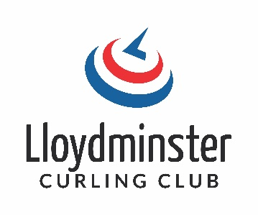
JUNIOR PROGRAM REGISTRATION FORM
2022/2023
LITTLE ROCKERS (Grades 3-7) Tuesdays 4:00pm to 5:15pm
Session One (Oct 18th to Dec 13th) (no Nov 8th) $70.00 _____________________
Session Two (Jan 10th to March 7th) (no Feb 21st) $70.00 ___________________
(Attend both sessions for $120.00)
HIGH SCHOOL (Grades 8-12) Wednesdays 4:00pm to 5:30pm
Session One (Oct 19th to Dec 14th (no Nov 9th) $90.00 _____________________
Session Two (Jan 11th to March 8th) (no Feb 22st) $90.00 ___________________
(Attend both sessions for $160.00)
Name: _______________________________________________
Address: ______________________________________________
Home Phone: _________________________________________
Birthdate: ____________________________________________
School: ______________________________ Grade: _________________
Parent Name (1): __________________________________________
Phone: __________________________________________________
Email: ____________________________________________________
Optional Parent Name (2): _____________________________________________
Phone: ______________________________________________________
Email: _______________________________________________________
All Funds are paid by E-Transfer to lloydcurling@gmail.com
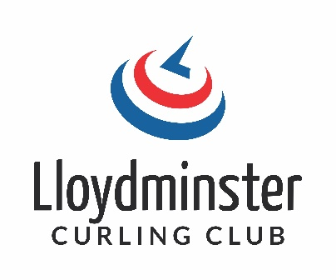
JUNIOR PROGRAM REGISTRATION FORM
2022/2023
What You Need to Know
We offer two different age groups so we can adjust the material offered to the kids based on experience. All experience levels are welcome, we can work with any skill level. We offer Little Rockers for the kids grade three to seven and High School for grade eight to twelve. The great thing about curling is you can start at any age.
Little Rockers is offered on Tuesdays 4:00 to 5:15pm and High School is offered on Wednesday 4:00 to 5:30pm. We do not have classes on the school breaks. We will be starting the week of October 18th and run for eight weeks. We then start a second session on the week of January 10th and run for another eight weeks. You can sign up for one session or sign up for both and save some money.
You only need to bring a clean pair of indoor shoes to play. The Lloydminster Curling Club can provide you with a broom, slider and gripper. A helmet is optional and you will need to bring your own. Remember it is played on ice, so dress appropriately.
We will have passionate instructors working with the kids that are very familiar with the basic skills and wanting to share their knowledge and love of the game.
If you are a parent looking to help out, or have questions please contact Nicole Reiniger, Junior Curling Coordinator, cell is 780-875-35936 or email lloydcurling@gmail.com. We always appreciate additional assistance.
QR Code to Registration Form

